NEPAL: COVID-19 Pandemic
Office of the UN Resident Coordinator Situation Report No. 46
As of 6 September 2021

This report is produced by Office of the Resident Coordinator in collaboration with partners. It covers the period from 21
August to 6 September 2021. The next report will be issued on or around 17 September 2021.

HIGHLIGHTS

• Heavy rainfall between 26-29 August affected thousands of people across the Tarai regions.

• Major roadways have been frequently obstructed by landslides and flooding, impeding humanitarian access to hard-to-reach areas. Humanitarian partners are coordinating with security forces on road clearance and access issues.

• Initial Rapid Assessments have been conducted in most affected areas, providing initial basic information on impacts. Several clusters are collecting more detailed sectoral information to plan interventions.
• Basic WASH, shelter/NFI and health support provided to households in heavily affected districts.
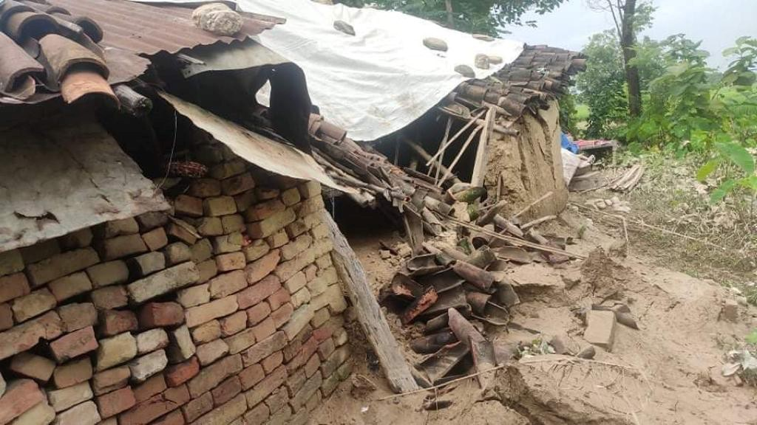

Flood damaged home in Nawalparasi, Lumbini. Source: UNICEF Nepal

• All clusters monitoring situation closely and on standby to provided additional response if needed.

31,248 | 10,838 | 18.8% | 302 | 5,940
Active cases | Total deaths | Case positivity | Affected palikas  (monsoon) | Affected HHs  (monsoon)

SITUATION OVERVIEW

Heavy rainfall from 26 to 29 August caused flooding and inundation in several areas across the Tarai. This resulted in nine deaths, four missing people, five injured and 756 being evacuated, with at least 42 houses completely damaged. A significant number of people have been affected by this flooding, particularly in Lumbini province. According to satellite imagery, around 90 thousand people were exposed to flooding and inundation in Nawalparasi, Rupendhi, and Kapilbastu. In Nawalparasi, around 4,500 houses were inundated. As flood water has receded in the area, most of the temporarily displaced population has returned; however, flood-affected households require support to recover their livelihoods and resume access to regular services. On 6 September, according to the Department of Hydrology and Meteorology (DHM), Kathmandu received 105 mm of rainfall in three hours (recorded at Kathmandu airport station), causing flooding in low lying areas along the rivers. More than 300 houses were inundated, and security forces rescued hundreds of people from affected areas.

Cluster have provided shelter/NFI, WASH and health related support in close coordination with local governments and district disaster management committees. A team comprising members from Nepal Red Cross Society, Nepal Police local units, and local governments carried out initial rapid assessments in affected areas.

The National Disaster Risk Reduction and Management Authority (NDRRMA) is planning to provide 50 thousand rupees
to affected households to cover temporary shelter and as a reconstruction grant, based on a technical assessment. On 29
August, NDRRMA convened a cluster lead and co-lead meeting to expedite the response to flooding in the Terai region.

Daily COVID-19 case numbers have been stable over the reporting period, with no rapid spikes, despite the gradual relaxation of containment measures such as lockdowns. The coming weeks will provide an important indication of containment in the absence of lockdowns as measures are mostly lifted.

PROVINCIAL UPDATES

Province One
• No major incident, but river level monitoring in ongoing and with water levels in Jhapa and Sunsari rising steadily
Distract Administration Offices are in response readiness phase with rescue boats on standby.
• Red Cross chapters have reported localized inundation in a few areas, resulting in crop damage but no causalities.

Province Two
• Moderate to heavy rainfall has affected hundreds of households in Mahotari, Salahi and Saptari.
• Embankment collapse along the Ratu River in Mahotari has causes a number of settlements to be inundated.
• Relief materials and data collection tools have been pre-positioned and there has been good coordination with palikas to provide support in the event of flooding.
• Security forces have been deployed for rescue operations and to repair embankments in Mahottari.
• Budgetary gaps remain at palika level for disaster response and relief.

Bagmati
• Monsoon impacts have been limited thus far, but Bagmati is heavily affected by Covid-19, with the majority of cases in the country.

Gandaki
• One health post has been inundated resulting in medicines being damaged and short-term service interruption.
• Road obstruction is on ongoing challenge, with the road to Pokhara frequently damaged and the road to Manang blocked since early monsoon.

Lumbini
• Lumbini is the first province to be heavily impacted by the 2021 monsoon season, with over 1,200 households affected across Nawalparasi, Rupendhi and Kapilbastu being most impacted.
• Some communities remain inundated and cut off from outside access.
• Nepal Red Cross Society has provided NFIs, including COVID-19 related (masks, sanitizer) to affected families.
• Major highways have been blocked by landslides in several places across the province.
• Humanitarian actors have been coordinating and working jointly to deliver assistance wherever possible.
• Needs remain for shelter support and some food items, as well as critical WASH response in inundated areas where tubewells have been contaminated.

Karnali
• Highway has been frequently obstructed during monsoon, but usually cleared overnight.
• 80 tarpaulins have been mobilized from pre-positioned stocks in Surket for landslide affected families in Darchula.
• Regular coordination among humanitarian actors is ongoing.

Sudurpaschim
• Heavy rainfall has led to flooding and landslide in Darchula, resulting in three deaths and two people injured.
• Ministry of Internal Affaris and Law is coordinating with CDOs in all nine districts and are on standby to respond to
monsoon impacts across the province based on needs identified by districts.
• Humanitarian partners are coordinating with security forces on clearance of frequent road blockages, which have made transportation of humanitarian supplies and rescue missions very difficult.
• Palikas struggle to fund relief items required.
• Partners are standing by to support palikas and other government levels on response gaps as needed.

CLUSTER RESPONSE

Health
• Provincial cluster meetings held and provision of support by some partners following request from NDRRMA to support Lumbini’s flood response.
• Provincial health stores have sufficient stocks to respond, and no visible health gaps are identified in any provinces.
• All health facilities are operational, accessible and coordinating with province and health authorities, including rapid response teams.
• Field teams are coordinating with hospitals for referral needs.

WASH
• 7,208 people (1,363 HHs) affected by monsoon events provided with basic WASH facilities in Manang, Pyuthan, Nawalparasi west, Rupandehi and Sindupalchok districts.
• Water purification tablets (650), buckets (650) and mugs (702) were provided to flood affected households in
Rupandehi (407) and Nawalparasi West (464).
• 2,854 people (492 HHs) from Manang, Pyuthan and Sindhupalchok were provided hygiene kits (440 sets), soap
(144 bars), buckets (2) and renovation of water supply (2).

Shelter
• Cluster members engaged in IRA process in various monsoon affected areas.
• In Ruphendi district 153 households have been displaced, and 20 families remain sheltered in schools. 63 families are sheltering at the roadside and others are being hosted by family.
• Cluster members are coordinating to respond to the need for temporary shelter with existing stocks.

Logistics
• Common service for transport and storage remains ongoing.
• Most medical cargo that has arrived at the has been dispatched to various provinces and hospitals.
• Limited supplies dispatched for monsoon response to date: tarps dispatched from Surkhet HSA to Darchula by helicopter on behalf of MoHA.
• Access constraint information updated regularly and disseminated to various partners.

CCCM
• Cluster members have supported affected and displaced families in Melamchi and Helambu families with CGI
sheets, nets, mattresses, tarps and tents.
• Coordination with agencies on the ground in Lumbini ongoing to obtain information on displaced populations and their locations. Most families are taking refuge in schools, though some are said to be living in open spaces.
• With water level receding people have begun to return, but not all are able to.
• No requests yet from partners or provinces to roll out Displacement Tracking Matrix (DTM).

Protection
• Melamchi and Sindhupalchok flood response psychosocial support (PSS) response activities remain ongoing.
• Planning for another round of capacity building as per request of two affected municipalities.
• IRA data is beginning to come in from Lumbini and Gandaki provinces, but cluster awaiting more detailed update on protection needs to plan interventions. Partners on standby to respond to GBV, PSS and child protection needs.
• Partners have been traveling to affected districts to collect detailed information and are providing various kits to the most vulnerable.
• Transportation is foreseen to be a major challenge; NRCS is already mobilized to enable access to services through provision of transportation services.

Food Security
• Food security situation is mostly stable, though localized monsoon events have created some supply disruptions.
• Prices of staple food remain stable, while vegetables prices have increased.
• Food stock in market sufficient to meet demand in all provinces.
• The latest round of mVAM (mobile vulnerability analysis and mapping) is now available.
• Local governments, NRCS and private sector organizations have responded to food needs during recent monsoon events. No immediate gaps identified, and no clusters partners have reported food security response.
• Employment generating programmes are prioritized response options for FSC to support vulnerable families in the informal sector, but resource mobilization has been a challenge for all cluster members.

Nutrition
• Therapeutic feeding programme ongoing in all affected districts.
• Activated simplified approach to treat SAM and MAM through ready to use therapeutic food.
• Additional supplies on standby for transportation to outpatient therapeutic feeding centers.
• Blanket supplementary feeding can be activated within 14 days if needed, but has not yet been demanded.
• SMART survey initiated in Saptari district and will soon cover all seven districts of Province Two.

Education
• With easing of lockdown, some palikas have started opening schools. Almost 2,000 schools have been reported open with safety protocols, but adherence levels are unclear.
• Emergency information has been integrated into the Education management information system (EMIS). 16 schools have been reported damaged by monsoon hazards and some budget has been allocated by government to reconstruct these buildings.

• Monsoon awareness messaging being broadcast on local radio, but response hindered by school closures.
• When monsoon subsides school reopening will become a pressing issue. Strong advocacy is needed to ensure children get back into classrooms safely.

Early Recovery
• Coordination with local partners ongoing, as well as with MoFAGA at the federal level.
• Regularly monitoring evolving context to determine if interventions from cluster members required.

