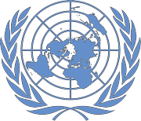NEPAL: COVID-19 Pandemic
Office of the UN Resident Coordinator Situation Report No. 36
As of 14 May 2021

This report is produced by Office of the Resident Coordinator in collaboration with partners. It covers the period from 1-14
May 2021. The next report will be issued on or around 21 May 2021.

HIGHLIGHTS

• Hospitals face shortages of oxygen, beds, essential supplies and trained human resources, have reached capacity and are turning patients away in many cities.

• Urgent need for vaccines and essential lifesaving commodities, including oxygen, critical care medicines and supplies, testing kits, PPE and temporary hospitals.

• Stop on flights will impact the ability to import essential commodities.

• Insufficient capacity to screen, test and monitor inflow of returnee migrants from India at land border points of entry before they travel back to their villages.

• Current messaging around self-care and caring for loved ones is generic and ineffective. Contextualized, locally relevant
messages are critically needed.

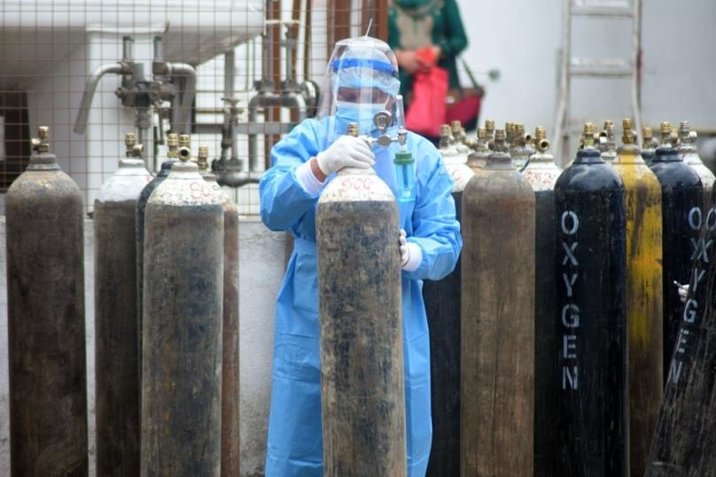
Source: UNDP/Laxmi Prasad Ngakhushi
.

105,207 | 108,004 | 46.7% | 431,191 | 4,466
Active cases | New cases  (reporting period) | Case positivity | Total cases | Total deaths

SITUATION OVERVIEW

COVID-19 infections are surging at an unprecedented rate in Nepal. The country of roughly 29 million people currently finds itself among the top ten countries in terms of absolute daily case increases, and has the highest effective rate of reproduction in the world. Test positivity has climbed just as quickly to over 45%, also the world’s highest, according to officially recorded figures. RT-PCR laboratory testing has reportedly reached the national capacity for daily tests, while use and access for Antigen RDT testing has not be adequately scaled up, largely due to shortages in supply.

Deaths have remained relatively low, but are increasing daily. With a much weaker health system than neighbouring India’s, Nepal is now at a critical juncture. Hospitals in major cities are at capacity and have had to turn patient away. Capacity is limited not only by physical infrastructure, but also by critical shortages in human resources and essential commodities such as oxygen.

Registration, health screening and Antigen RDT testing of all entrants to Nepal through land border points of entry (PoE) health desks is inadequate, as is community level surveillance, case investigation and contact tracing, severely impacting the ability to monitor and control the spread of the virus in Nepal.

The Ministry of Health and Population has released a list of essential health commodities urgently required for the response, and the humanitarian community is working to address these gaps, and the Minister of Health further highlighted the urgent need for oxygen, critical care medicines and supplies and temporary hospitals. The Social Welfare Council has requested all I/NGO members to divert 5-20% of their resources to the COVID-19 response. A consolidated COVID-19 Response Plan for the humanitarian community will be released early next week.

PRIORITY NEEDS

Health
• Essential lifesaving commodities, including oxygen supplies (60,000 cylinders, 2,000 concentrators, 10 tanks, 7 plans and 1,000 high flow nasal canula), testing supplies (RT-PCR and Antigen RDT), critical care medicines and supplies, temporary hospitals and PPE.
• Vaccines (1.7 m needed immediately for 2nd dose vaccination of those over 65 years).
• Critical need for human resources to provide facility-based support to manage case surges, tele-medicine for management of safe home-isolation and information management support for institutions managing public health interventions.
• Enhanced public health and social measures that ensure universal application.
• Registration, health screening and testing with Antigen RDT for all entrants at all points of entry (PoEs).

WASH
• Establishment of hand washing stations in health care facilities.
• Provision of WASH and IPC supplies for health teams, including sanitations workers, in health care facilities, isolation centres and at points of entry (PoEs).

Logistics
• Information management support to track all government requests and pipeline for medical supplies offered by humanitarian agencies and development partners.
• Support for establishment of holding areas for returnees at borders, as requested by provincial governments.

Risk Communication and Community Engagement
• Increase efforts on communication with communities on risk prevention, home based care and referral and IPC, including engagement with municipalities, security personnel, youths and humanitarian actors on promotion and monitoring of behaviours and community support.
• Focused efforts on communication at points of entry, with aligned key messages and holistic approach.

CCCM
• Requests from provincial and local governments for life-saving equipment - ventilators and oxygen concentrators.
• Support provincial governments in establishing adequate temporary holding centres in open spaces.
• Enhance capacity of frontline workers to better manage and operate holding/isolation centres.

Protection
• Identification, transportation and interim accommodation support for vulnerable returnees at PoEs.
• Ensure continuity of protection services, including referrals and identification of specific protection risks.
• Psychological first aid services and socio-economic support to vulnerable groups, particularly those in isolation.

Nutrition
• Supplementary food support to pregnant and lactating women in isolation centres.
• Engage at local level to expand outpatient management of acute malnutrition to health posts and via female community health volunteers using adapted treatment protocols designed for the COVID-19 context.

Education
• Provide children access to alternative learning resources, particularly self-learning materials
• Create mechanisms to monitor reach and effectiveness of these resources, recover lost learning, and support teachers.

Food Security
• Urgent need to ensure access to food through functioning markets as well as support to farmers in remote and highly affected areas.

Cash Coordination
• Provision of immediate relief and recovery support to the most vulnerable population.
• Vertical top-up to families receiving the child grant in palikas with high impacts and lockdowns.

Gender in Humanitarian Action
• Medical supplies (oximeter, thermometer, PPE and paracetamol) in women’s shelters with outbreaks.
• Ensure access to food and COVID-19 health services for excluded groups such as Dalit, indigenous and single women.

OPERATIONAL RESPONSE

Health
• Working closely with partners to identify opportunities for support, including capacity building in clinical care, dissemination of IEC materials, development of health bulletins, translating MoHP Incident Command System decisions to actions, development and support to implementation of public health social measures (PHSM) materials, and identification of commodity support for health systems
• Communication with COVID hospitals and Provincial Health Directorate offices to understand needs and gaps in human resources, risk communication, commodities, and IPC/case management

WASH
• Providing support with WASH supplies and facilities in four PoEs and expanding to others.

Logistics
• Transportation services including three trucks carrying oxygen cylinders to/from Dhangadhi and Nepalgunj and one truck carrying medical items from Biratnagar.
• Three mobile storage units established or being prepared for holding centres in Nepalgunj and Dhangadhi and as a central medical store in Pathlayia.
• In-country transport of essential cargo is currently not restricted despite district lockdowns and humanitarian staging areas are expected to have sufficient storage capacity.

CCCM
• Provision of masks, sanitizers, and PPE to provincial and local governments for distribution at isolation centres, hospitals and PoE, among others.

Protection
• Incident monitoring activated in Lumbini, Province Two, Karnali and Sudurpaschim and is being scaled up to all provinces.
• 12 helplines activated, including Child Helpline emergency services (emergency rescue, etc.).
• Community psychosocial workers deployed at a total five PoEs and plans for further deployments underway.
• Promotion of emergency protection services initiated at PoEs and in communities in collaboration with RCCE and private sector.
• Rapid assessments planned and being coordinated with cluster members in 16 districts.

Nutrition
• Ongoing dissemination of nutrition and COVID-19 related messages throughout the country via radio.
• Ongoing supplementary feeding programme in five districts of Karnali province, Solukhumbu district of Province
One and three palikas of Saptari district targeting 6-23 months children and pregnant and lactating women.

Food Security
• Preparation of a series of rapid monitoring to assess the food security/livelihoods situation and inform the scale of a potential response: mobile Vulnerability Analysis and Mapping and market assessments complemented by Minimum Expenditure Basket (MEB).

Cash Coordination
• Government identified 1.7 million vulnerable households in May 2020 who were supported through in-kind transfers through provincial and local governments, and are in the COVID-19 management information system. These families could be immediately supported with cash transfers in line with MEB guidelines.

KEY GAPS AND CHALLENGES

Health
• Procurement of essential commodities challenged by a lack of national suppliers and a resulting requirement to import (Antigen testing and specialized equipment for treatment such as oxygen concentrators, etc.)
• Critical shortage of trained human resources, such as critical care specialists and a lack of funding at provincial and local levels to mobilize desperately needed capacity in key districts and palikas.
• Lack of adherence to public health and social measures at local levels, which are essential to break the chain of transmission.

WASH
• Funds and commitments of cluster members are very limited compared to those available in the first wave due to a lack of funds for 2021.
• Many WASH frontline teams are affected by COVID-19. Direct engagement of WASH workforce is limited due to fear of infection.
• Municipal/community-based isolation centres are being set up with limited capacity and services, including WASH/IPC facilities. Proper management of these facilities could reduce the burden on health care facilities and home isolation.

Logistics
• The stop on international flights restricts air transport of critical health supplies and humanitarian staff to Nepal.
• Transportation of 60,000 oxygen cylinders to Nepal will require 375 truckloads or 150 flights; customs clearance at Nepal-China border will be challenging.

RCCE
• Current messaging around self-care and caring for loved ones at home or in the hospital is generic and ineffective. Contextualized, locally relevant messages are critically needed.
• Stronger collaboration required at PoEs to ensure reach, quality of messaging and feedback loops.
• Limited partners involvement in community engagement to disseminate standardize messages and approaches.

CCCM
• Lack of appropriate infrastructural set-up of health desks and holding centres.
• Lack of human resources and support from development agencies at health desks to screen all returnee migrants before allowing them to travel to their respective districts and monitor inflow to country and districts.
• Lack of immediate psychosocial services for frontline workers and returnee migrant workers.
• Lack of hygiene kits and immediate medical supplies.
• Lack of masks, sanitizers, and PPEs for front line workers at PoEs.
• Lack of dedicated transportation services (ambulance/vans) at PoEs for suspected COVID-19 cases.
• Lack of IEC materials (including self-health care during isolation) to be distributed to returnee migrants.

Protection
• Service providers from helplines, shelters and at times OCMCs have faced mobility constraints. The continuity of these essential services depends on facilitating mobility, access to PPE and access to vaccination services.

Nutrition
• Health staff are overwhelmed by COVID-19 care, limiting capacity for other essential health and nutrition services.
• Screening children for wasting continues to be constrained due to lockdown and other public health measures .

Education
• Constraints on local printing services to facilitate production and distribution of self-learning materials is increasing educational barriers of disadvantaged children without access to devices.

Gender in Humanitarian Action
• Women with physical disabilities are finding it difficult to access food/medicine supplies during lockdowns.
• Single women groups have highlighted that those in home isolation are struggling to receive nutritious food.

Cash Coordination
• Lack of central level guidance on use of cash transfer as a COVID-19 response modality.

For further information, please contact:
Prem Awasthi, Humanitarian Coordination Officer, prem.awasti@one.un.org, Tel: +977 9858021752

