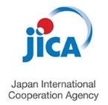Basic Operating Guidelines agreed to by the Undersigned Agencies in Nepal

pport
DANIDA
Programme Support
DANIDA
Programme Su

Based on the principles of Accountability, Impartiality, Transparency, and Inclusion, agreed upon internationally and in Nepal, we the undersigned have adopted the following Basic Operating Guidelines for all development and, if necessary, humanitarian assistance to the people of the Federal Democratic Republic of Nepal.

1. We are in Nepal to contribute to the improvements in the quality of life of the people of Nepal. Our assistance focuses on reducing poverty, meeting basic needs, and enabling communities and the country to meet their development aspirations.
2. We work as per agreements with the Government of Nepal and through the freely expressed wishes of local communities. We respect the dignity of people, their culture, religion, and customs.
3. We provide assistance to the poor and marginalized people of Nepal, regardless of where they live and who they are. Assistance is based on needs and priorities shared by Nepal and the contributing country or organization alone and not on any political, ethnic, religious, or other
agenda.
4. We ensure our assistance is transparent to the government and communities impacted and we involve our intended beneficiaries, their communities, and representatives in the planning, management, and implementation of programmes. We are accountable both to those whom we seek to assist and to those providing the resources.
5. We seek to ensure that our assistance tackles discrimination and social exclusion, most notably based on gender, ethnicity, caste, and religion.
6. We recruit staff on the basis of suitability and qualification for the job, and not on the basis of political or any other considerations.
7. We do not accept our staff and development partners being subjected to any manner of violence,
abduction, harassment, intimidation, or threats. We urge all those concerned to maintain an operating environment that supports the unhindered implementation of our programmes and safety of our staff.
8. We are committed to preventing and responding to allegations of sexual exploitation, harassment and abuse affecting our beneficiaries, staff and delivery partners.
9. We do not work where staff are forced to compromise our core values and principles.
10. We do not accept our resources being used for any violent, sectarian, or other purposes beyond our stated programme aims.
11. We do not make donations in cash or kind, forced or voluntary to any groups or political parties, or affiliated organizations, beyond our stated programme purposes.
12. The equipment, supplies, and facilities funded through our resources are not used for purposes other than those stated in our programme objectives. Our vehicles are not used to transport persons or goods that have no direct connection with the development programme. Our vehicles do not carry armed or uniformed personnel.
13. We do not tolerate the theft, diversion, or misuse of development or humanitarian assistance.
14. We urge all those concerned to allow full access by development and humanitarian personnel to all people in need of assistance and, to promote their safety, security, and freedom of movement in the implementation of development programmes.
15. We expect and encourage all actors concerned to comply strictly with international humanitarian and human rights laws.

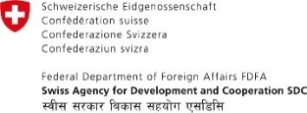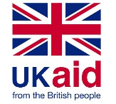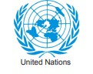

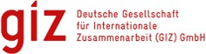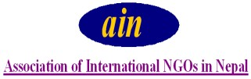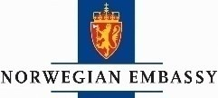

Korea International
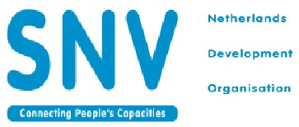Cooperation Agency

